Lab task 1

* This lab task one deals with the creation of database and table in MYSQL.
* Establishing connection between MYSQL and PHP
* Creating HTML form and inserting record from HTML form to MYSQL
* Displaying records from MYSQL to Web Browser.
* Editing Records and updating records
* Deleting records.

Creating database in MYSQL

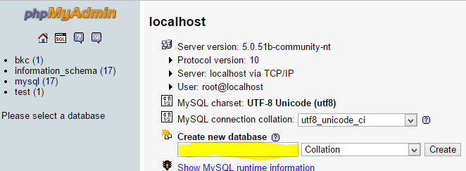

Steps to create database

1. Start wamp server
2. Choose phpmyadmin
3. Write name of database in colored section

Creating Table

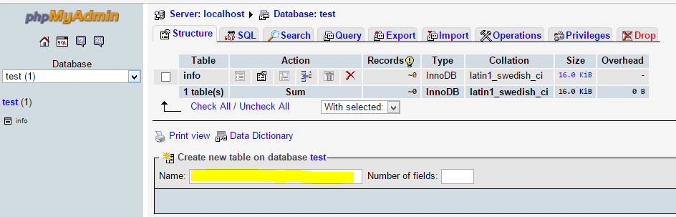

Steps to create table

Table can be created in MYSQL in different ways

1. Using query
2. Using design view

1. Connecting with database from PHP (db_connect.php)

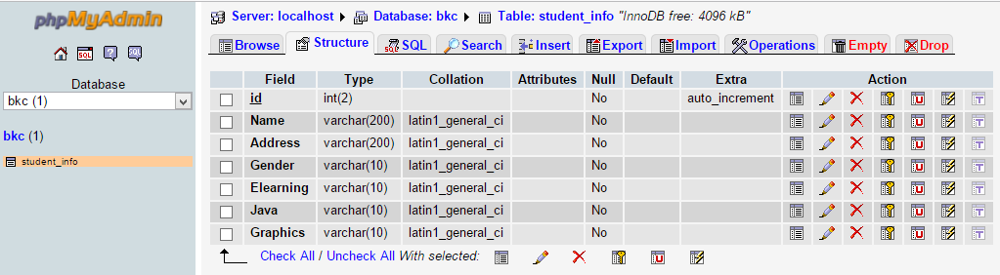

<?php

$db=mysql_connect('localhost','root','') or die('unable to connect to database');

$conn=mysql_select_db('bkc',$db) or die(mysql_error($db));

if($conn)

{

echo'database connected';

}

?>

2. Creating form to input record(html_form.html)

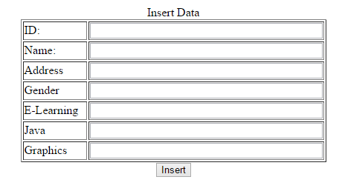

<html>

<head>

<title>Form Input Data</title>

</head>

<body>

<center>

<form method="post" action="input.php">

<table width="411" border="1">

<caption>

Insert Data

</caption>

<tr>

<td width="155">ID: </td>

<td width="240"><input type="text" name="id" size="40"></td>

</tr>

<tr>

<td>Name:</td>

<td><input type="text" name="name" size="40"></td>

</tr>

<tr>

<td>Address</td>

<td><input type="text" name="address" size="40"></td>

</tr>

<tr>

<td>Gender</td>

<td><input type="text" name="gender" size="40"></td>

</tr>

<tr>

<td>E-Learning</td>

<td><input type="text" name="elearning" size="40"></td>

</tr>

<tr>

<td>Java</td>

<td><input type="text" name="java" size="40"></td>

</tr>

<tr>

<td>Graphics</td>

<td><input type="text" name="graphics" size="40"></td>

</tr>

</table>

<input type="submit" name="submit" value="Insert">

</form>

</center>

</body>

</html>

1. Codes to insert records from HTML to MYSQL(input.php)

<?php

//the example of inserting data with variable from HTML form

include("db_connect.php");

// Get values from form

$id=$_POST['id'];

$name=$_POST['name'];

$address=$_POST['address'];

$gender=$_POST['gender'];

$elearning=$_POST['elearning'];

$java=$_POST['java'];

$graphics=$_POST['graphics'];

//inserting data order

$order = "INSERT INTO student_info

(id,Name,Address,Gender,Elearning,Java,Graphics)

VALUES

('$id','$name','$address','$gender','$elearning','$java','$graphics')";

//declare in the order variable

$result = mysql_query($order); //order executes

if($result)

{

echo"<br>";

echo("Record inserted sucessfully");

}

else

{

echo"<br>";

echo("Input data is fail check your connection");

}

?>

1. Display Records form MYSQL to Web page (displayintable.php)

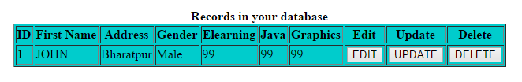

<head>

<meta http-equiv="Content-Type" content="text/html; charset=utf-8" />

<title>Untitled Document</title>

</head>

<?php

include("db_connect.php");

?>

<body>

<table border=1>

<tr>

<th>ID</th>

<th>First Name</th>

<th>Address</th>

<th>Gender</th>

<th>Elearning</th>

<th>Java</th>

<th>Graphics</th>

</tr>

<?php

//create the query

$result = mysql_query("select * from student_info");

//return the array and loop through each row

while ($row = mysql_fetch_array($result))

{

?>

<tr>

<td><?php echo $row['id'];?></td>

<td><?php echo $row['Name'];?></td>

<td><?php echo $row['Address'];?></td>

<td><?php echo $row['Gender'];?></td>

<td><?php echo $row['Elearning'];?></td>

<td><?php echo $row['Java'];?></td>

<td><?php echo $row['Graphics'];?></td>

</tr>

<?php

}

?>

</table>

</body>

</html>

Delete.html

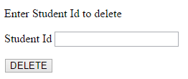

<html xmlns="http://www.w3.org/1999/xhtml">

<head>

<meta http-equiv="Content-Type" content="text/html; charset=utf-8" />

<title>Untitled Document</title>

</head>

<form name="form1" method="post" action="delete.php">

<p>Enter Student Id to delete</p>

<p>Student Id

<input name="id" type="text">

</p>

<p>

<input type="submit" name="Submit" value="DELETE">

</p>

</form>

<body>

</body>

</html>

Delete.php

<?php

include("db_connect.php");

// Get values from form

$id=$_POST['id'];

$name=$_POST['name'];

$address=$_POST['address'];

$gender=$_POST['gender'];

$elearning=$_POST['elearning'];

$java=$_POST['java'];

$graphics=$_POST['graphics'];

$query="delete from student_info where id ='$id'";

$check=mysql_query($query);

include("displayintable.php");

?>

Editing Records in database

Edit.html



<head>

<meta http-equiv="Content-Type" content="text/html; charset=utf-8" />

<title>Untitled Document</title>

</head>

<body>

<form id="form1" name="form1" method="get" action="edit-record.php">

<p>Enter roll no to edit</p>

<p>

<input type="text" name="id" id="id" />

<input type="submit" name="button" id="button" value="Submit" /></p>

<p>&nbsp;</p>

</form>

</body>

</html>

edit_action.php

<head>

<meta http-equiv="Content-Type" content="text/html; charset=utf-8" />

<title>Untitled Document</title>

</head>

<body>

<?php

$id=$_POST['id'];

$name=$_POST['name'];

$address=$_POST['address'];

$gender=$_POST['gender'];

$elearning=$_POST['elearning'];

$java=$_POST['java'];

$graphics=$_POST['graphics'];

$con=mysql_connect("localhost","root","");

mysql_select_db("bkc");

$sql="update student_info set Name='$name', Address='$address', Gender='$gender',Elearning='$elearning',Java='$java',Graphics='$graphics' where id=$id";

mysql_query($sql,$con) or die(mysql_error());

if(mysql_affected_rows($con)==1)

echo("record updated successfully");

mysql_close();

include("displayintable.php");

?>

</body>

</html>

Edit-record.php

<?php

ob_start();

?>

<!DOCTYPE html PUBLIC "-//W3C//DTD XHTML 1.0 Transitional//EN" "http://www.w3.org/TR/xhtml1/DTD/xhtml1-transitional.dtd">

<html xmlns="http://www.w3.org/1999/xhtml">

<head>

<meta http-equiv="Content-Type" content="text/html; charset=utf-8" />

<title>Untitled Document</title></head>

<body>

<?php

$id=$_GET['id'];

if(!is_numeric($id))

{

header("location: update.html");//runs to the given location we have to start ob_start tag to use header

exit;

}

$con=mysql_connect("localhost","root","");

mysql_select_db("bkc");

$sql="select *from student_info where id=$id";

$result=mysql_query($sql,$con)or die(mysql_error());

if(mysql_num_rows($result)==0)

{

echo("<font color=red size=2 > no record found</font>");

exit;

}

$data=mysql_fetch_assoc($result); print_r($data);

?>

<form id="form1" name="form1" method="post" action="edit_action.php">

<table width="411" border="1">

<caption>

Edit Record

</caption>

<tr>

<td width="155">ID: </td>

<td width="240"><input type="text" name="id" size="40" value="<?=$data['id']?>"></td>

</tr>

<tr>

<td>Name:</td>

<td><input type="text" name="name" size="40" value="<?=$data['Name']?>"></td>

</tr>

<tr>

<td>Address</td>

<td><input type="text" name="address" size="40" value="<?=$data['Address']?>"></td>

</tr>

<tr>

<td>Gender</td>

<td><input type="text" name="gender" size="40" value="<?=$data['Gender']?>"></td>

</tr>

<tr>

<td>E-Learning</td>

<td><input type="text" name="elearning" size="40" value="<?=$data['Elearning']?>"></td>

</tr>

<tr>

<td>Java</td>

<td><input type="text" name="java" size="40" value="<?=$data['Java']?>"></td>

</tr>

<tr>

<td>Graphics</td>

<td><input type="text" name="graphics" size="40" value="<?=$data['Graphics']?>"></td>

</tr>

</table>

<input type="submit" name="button" id="button" value="update" /></p>

</form>

</body>

</html>